EDSPLORE HONG KONG & MACAU
PROGRAM DURATION 5N/6D JUNE,26 20262026

We are thrilled to extend an exclusive invitation for your child to join our upcoming 5N/6D Educational Trip to the enchanting Hong Kong, scheduled for June 2026. Prepare for an unparalleled adventure as we unveil the detailed itinerary for your child's extraordinary journey. To secure their spot, kindly fill in the consent form and send it with the package cost via cheque or online transfer by 15th May 2026.

EDSPLORE HONGKONG
PROGRAM DURATION 5N/6D TIME OF TRAVEL: JUNE 2026

Organised by 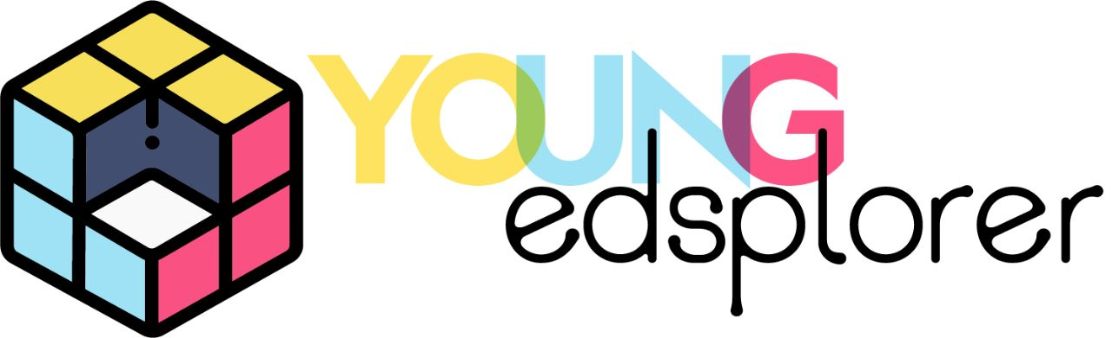

--------------
Payment Guidelines:
The total cost of the program is INR 1,51,000 price includes (visa fees, travel insurance, airfare, hotel, airport transfers, all attractions and all meals each day as mentioned in the itinerary.)

Payment to be made via cheque only in favour of school by Friday 15th May 2026 and to be deposited on Gate No.4

Cancellation Policy:
The following Cancellation Policy is applicable for all Young Edsplorer’s International
Travel Programs.
1. From the date of registration till 60 days before the departure date: An amount
of INR 20,000/- + GST (Non Refundable) + VISA Fee and Air ticket Cancellation as per
actual if applicable.
2. 59 days till 30 days before the departure date: 50% of the total payment/- + GST (Non Refundable) will be applicable.
3. Cancellation within 29 days to 11 days before the departure date: 75% of the
total payment/- + GST (Non Refundable) will be applicable.
4. Cancellation within 10 days before the departure date: No refund will be made.
5. In case of VISA is denied to your child, you will be liable to bear deduction of INR
15,000/- + GST + Air ticket cancellation (as per actual) or any other payment made to the supplier (as per actual)
The applicant should notify the company in writing at (clientdesk@youngedsplorer.com) Cancellation will be calculated from the day the email is received. NO VERBAL CANCELLATIONS WOULD BE ENTERTAINED.

I have understood the parental consent and cancellation policy, hence agree to send my child for the trip, I shall adhere to the consent & cancellation policy and will not challenge the decision of Young Edsplorer Pvt. Ltd. New Delhi, in any context.
Detailed Itinerary
Day 1: INDIA- HONG KONG
Meet your journey leader and departure
Fly as per schedule (6hrs)
Arrival in Hong Kong
Lunch, hotel check in & freshen up
Evening visit Bruce Lee statue
Enjoy Avenue of Stars & Symphony of Lights at
Darling Harbor
Dinner & overnight stay at hotel
Meals: As per flight Schedule

Day 2: HONG KONG – HKU + HKMA
Breakfast at the Hotel
Proceed for Hong Kong University HTU – guided tour of the university
Visit to Ngong Ping and Tian Tan Big Buddha
Ngong Ping 360 offers experiential learning,
including STEAM-focused
programs like "Cable Car Minigineer" and "Mochi
the Robot" that teach engineering, sustainability,
and robotics
Understand the working of Cable car ride on
Ngong Ping 360
Visit to Tian Tan Buddha and Po Lin Monastery
Lunch
Evening Explore local markets / Kong Night Street Market
Dinner & Overnight at Hotel
Meals: Breakfast, Lunch, Dinner

Day 3: HONG KONG – DISNEYLAND
Breakfast at the Hotel
Full day Hong Kong Disney Land
Lunch voucher
Dinner & Overnight at Hotel
Meals: Breakfast, Lunch, Dinner

Day 4: HONG KONG- OCEAN PARK
Breakfast at the Hotel
Full Day Ocean park
Lunch voucher
Evening pick-up
Dinner & Overnight at Hotel
Meals: Breakfast, Lunch, Dinner

Day 5: HONG KONG – MACAU – HONG KONG
Breakfast at the Hotel
Proceed to the Hong Kong Pier to board the Ferry to Macau
Team Lab Super Nature Macao – It is an extremely
complex, three-dimensional interactive space.
Immerse the body in a complex, three-dimensional
world, create a world with others, and become
one with that world.
Lunch voucher
Macao Grand Prix Museum – Here you will re-live
the fascinating history and see the Grand Prix cars and
motorcycles from across the decades and learn
about the drivers, riders, teams and personalities
who have made their mark on this captivating story
since 1954.
Macau Tower - Discover the unparalleled view
of Macau from an exceptional vantage point elevated
at a height of 223 meters above ground level. The
Observation Deck, featuring three-storey
glass windows, provides an unparalleled 360-degree
panoramic view of the city.
Evening return to Hong Kong by Ferry
Dinner & Overnight at Hotel
Meals: Breakfast, Lunch, Dinner

Day 6: DEPARTURE
Breakfast at the Hotel
Visit to the Hong Kong Monetary Authority
Hong Kong Monetary Authority (HKMA) is
the government authority in Hong Kong
in charge of maintaining monetary and
banking stability. Founded in 1993, it now
reports to the Financial Secretary.
The HKMA tour includes an expert guide
Free time for shopping Lunch
Board the Flight to India as per flight schedule
Night arrival at Delhi airport
Meals: As per Flight Schedule

